/  Mobile–9900244330  karuna.devanagavi@gmail.com  (Immediatly available) | Karuna Devanagavi  Sr Software Engineer
Key Skills and Knowledge  Big Data Hadoop  Java(core)  J2EE  Open Source Big Data Languages & Tools  (Hadoop Stack)  MapReduce  Pig  Hive  Flume  Sqoop  HBase  Apache Oozie  Zookeeper  Hadoop 2.0  HDFS-HA  HDFS Federation  YARN  MRv2  NoSQL Databases  HBase  Cassandra  Hadoop Distributions  Cloudera  Apache  Programming Languages & Tools  Java(core)  JDBC  Servlet  JSP  Struts 2.0  Spring  Hibernate  Eclipse IDE  Apache JMeter  Windows Diff Doc  Databases  Oracle  Sybase  Postgres SQL  SQL Server  Web/Application Servers  Tomcat  JBoss  WebLogic  Domain Expertise & Solutions  Web Security  Management  Automation |  | Skills Summary  Strong development skills across the Full Hadoop Stack. Exposure or desire to work with emerging Big Data technologies.  3.9 years of experience in developing various applications in Java / J2EE. Involved in requirements, design, development and testing of java based enterprise applications.  Project Experience – Hadoop  - Installing and setting up Pseudo Distributed Cluster using Apache Hadoop and also setup the Multi Node Cluster on a single machine for the testing purpose using the VMware tool (CDH3,CDH4 and Multinode cluster).  - Installing and setting up Single-Node Apache Hadoop 2.0 Cluster on Ubuntu.  - Installing, configuring and testing hadoop ecosystem components.  - Data loading into the Hadoop Distributed File System (HDFS).  - Used Apache Flume to get the tweets from the Twitter account.  - Data loading techniques using Scoop -- From RDBMS to HDFS Import and from HDFS Export to RDBMS (Oracle,MYSql and Sql Server).  - Importing and Exporting data into HDFS and Pig, Hive using Scoop.  - Capable of processing large datasets of structured, semi-structured and unstructured data.  - Developed and executed MapReduce programs for different datasets to parse the raw data.  - Developed and executed PIG Scripts for various kind of datasets.  - Data loading in Hive and understanding of Hive Query Language.  - Data loading and Querying in HBase and ZooKeeper.  - Oozie Workflow and ZooKeeper coordination service.  - Hadoop 2.0 –- HDFS-HA, HDFS Federation, YARN, MRv2.  - Capable of working on Linux for Hadoop.  Project Done  Project 1  Project Name: Analysing Queens Library Branches.  Environment: Multi Node Cluster on a single machine for the testing purpose using the VMWare tool, HDFS, Pig, Sqoop, Mysql.  Project Description:  This data set is list of NewYork’s Queens Library branches and the timings of the library when it will be open on each day of the week. If the library is not opened then that field will have the value Closed. The data Analysis includes the total number of libraries located in the NY Queens region, the total number of the libraries and their name that are open on Sunday and the total number of libraries that are no more working in the Queens region and their names.  Roles and Responsibilities:  - Involved in moving all the data files to HDFS for further processing.  - Written the Apache PIG scripts to process the HDFS data.  - Using Sqoop exported Pig processed output data into Mysql.  Project 2  Project Name: Market Evaluation.  Environment: Multi Node Cluster on a single machine for the testing purpose  using the VMWare tool, HDFS, MapReduce, Hive.  Project Description:  Market Evaluation gives the information about the markets and the products available in different regions based on the seasons. By Select any particular county and calculating the percentage of different products produced by each Market in that particular county. Here we have total 24 products which consists of the value Y or N. Count the products that a particular market will produce will be Y and calculate percentage as count%25. Divide the products into three categories High, Medium and Low and Find the count of the markets that come under the category High, Medium and Low.  Roles and Responsibilities:  - Involved in moving all the data files to HDFS for further processing.  - Developed MapReduce application using MapReduce programming.  - Involved in running the MapReduce jobs for given data set.  - Created Hive tables and stored the processed results in a tabular format.  Project 3  Project Name: Analysing the SAT  Environment: Multi Node Cluster on a single machine for the testing purpose using  the VMWare tool, HDFS, Pig, Hive, HBase.  Project Description:  This data set is SAT(College Board) 2010 School level results which gives the information about how the students perform in the tests from different schools. Analysing the SAT includes finding the total number of test takers, highest mean/average of the Critical Reading section and the school name, highest mean/average of the Mathematics section and the school name and highest mean/average of the Writing section and the school name.  Roles and Responsibilities:  - Involved in moving all the data files to HDFS for further processing.  - Written the Apache PIG scripts to process the HDFS data.  - Created Hive tables to store the processed results in a tabular format.  - Monitoring Hadoop scripts which take the input from HDFS and load the data into Hive.  - Created external tables in Hive.  - Also created HBase tables to store the processed results  Project 4  Project Name: Analyzing Book-Crossing Data  Environment: CDH3(Cloudera Distribution Including Apache Hadoop), HDFS, Pig.  Project Description:  The Book-Crossing dataset consists of 3 catagories Users, Books and Book-Ratings. The book-crossing data analysis includes finding the frequency of books published each year, find out in which year maximum number of books were published and out how many book were published based on ranking in the year 2002.  Roles and Responsibilities:  - Involved in moving all the data files to HDFS for further processing.  - Written the Apache PIG scripts to process the HDFS data.  Project Experience - Java  Unisys Global Services India.  Application Defender. Dec 2006 – Mar 2009  Application Defender enables you to add protection to Java Web applications to help secure those applications against common vulnerabilities. The Application Defender agents are installed on the servers hosting applications to be protected. These agents monitor the servers for local changes in application server instances, configurations, and applications.  Role: Involved in gathering requirements design, coding and implementation of new protection bits to current system. Worked on implementation of JavaScript .js files present in the applications, masking the field for user defined regex pattern, Stress (load) testing using jmeter, Through testing of all protection bits.  Tools: Java, RMI, JNDI, AspectJ, AspectJS, Ant, Eclipse IDE, SWT, Jboss, Tomcat, Weblogic, Websphere.  Wipro Technologies.  CEFS. Mar 2006 – Dec 2006  Corporate Employee Financial Services is web application provides comprehensive stock benefit plans. Companies will grant stock options to their employees based on the category of the employee. Companies will have different stock plans ie ESPP, ESOP, RSA, SAR. CEFS has three main modules, one source module, webadmin module, financial module. CEFS 2.1 release one source has RSA Performance award tax election notification. The performance award given to those participants who meet the performance criteria set by company. If the participant has performance award then the notification will be displayed to participant informing that he has to pay the tax. So for that he has to choose the tax election method, share delivery method and cash proceed method.  Role: Involved in design, coding and testing of RSA performance awards.  Tools: Struts Framework. Web sphere Studio Application Developer 5.1, Sybase.  Larsen and Toubro InfoTech.  CAFÉ. Oct 2005 – Mar 2006  The mobile application development is wireless technology. The new generation mobiles F700i and N700i are developed by using I-Mode technology. The main goal behind developing F700i and N700i is to access the Internet through i-Mode. i-Mode is wireless packet technology that allows the Internet access in cellular phones. The new feature added to the i-Mode is called DoJa (DoCoMo’s Java). Application written in DoJa is referred as i-Appli. DoJa is similar to the Sun Microsystems’s MIDP Implementation.  Role: Involved in the test procedure modification and test application modification.  Tools: J2ME, Visual source safe  Employment History  - Sr. Software Engineer, Unisys Global Services India. Dec 2006 – Mar 2009.  - Software Engineer, Wipro Technologies. Mar 2006 – Dec2006.  - Software Engineer, Camo Software India Pvt Ltd (Out sourced to Larsen and Toubro InfoTech). Oct 2005 – Mar 2006.  Education  MSc. (Computer Science) passed First class with Distinction in 2003 with 72% from Basaveshwara Science College Bagalkot, of Karnataka University Dharwad.  Professional Certification  Sun Certified Java Programmer (SCJP - Java 1.5)  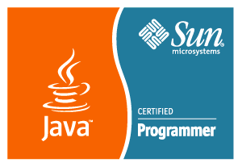  Course Certification  An Edureka! Certified BIG DATA EXPERT with grade A  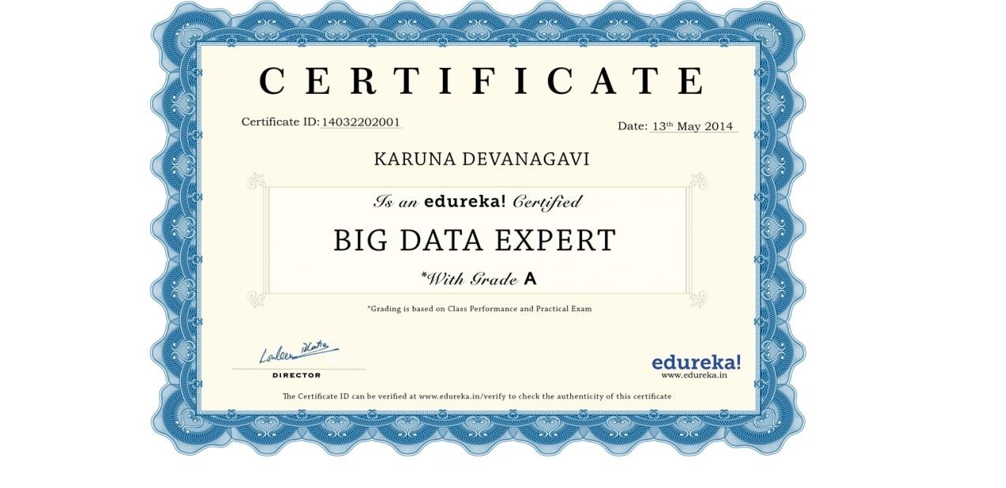  Certificate ID : 14032202001  The certificate id can be verified at www.edureka.in verify to check the authenticity of the certificate.

